SW06 – Advanced Object-Oriented Programming
Development Project – Stage 3
Submission deadline: 10 May 2004, 14:00 (start of tutorial)

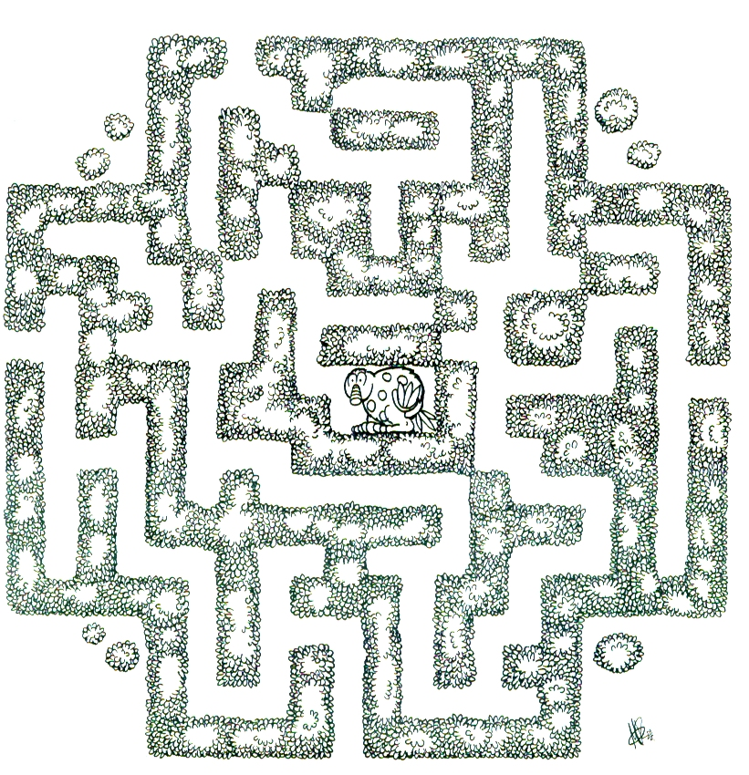
Overview
This last stage of the project implements interaction via reflection.
The goal is to allow individual interaction with characters or classes of characters at runtime. When a player plays the game, she can meet characters, and individual methods can then be invoked on the characters. These methods are not known at compile time – they are discovered at runtime via reflection and made available to the player in the user interface.
A possible design is to display a UI element (an icon) for each character in view, and offer a popup menu displaying all the interactively invokable methods of that character.

Requirements
The following are minimum requirements that must be fulfilled.
- Characters at the current location of the player must be shown.
- The application must provide interactive access to some methods of each character.
- All methods of the character starting with the prefix “im” (for “interactive method”) must be accessible in the interface.
- Interactive methods can have return values and parameters.
You have to decide how to deal with parameters - there are many different possibilities, the decision is up to you.

Deliverables
This project stage consists of three deliverables: a presentation, a report and source code.
The presentation: all projects will be demonstrated in weeks 20 and 21. Project presentations will be in the tutorial and lecture time slots (details will be discussed later). Each presentation must include
- some background information (game idea, design, etc);
- a live demo;
- discussion of selected topics of interest. These are most likely design decisions to achieve code quality in terms of flexibility, maintainability, etc., and discussion of interesting problems encountered;
- comments on your experiences with exchanging characters with other groups;
- discussion of the work process: pair programming, testing, use of JUnit: successes and problems.
Presentation time: 20 minutes (including 2 minutes for questions). Please note that the goal of the presentation is not to present your complete game, but to talk about software engineering aspects of your project!
The report should include all topics mentioned for the presentation (with exception of the demo, of course), plus some additional sections. These include: known bugs and problems; ideas for further improvements, reflective comments on application design; reflective comments on work process.
The report must include a class diagram and source code printout.
The complete project source code must be submitted electronically before the deadline by email to mik@mip.sdu.dk.

Assessment
There is no separate assessment for this stage of the project. However, completing this project is a prerequisite for attendance of the final exam.
The project report will form the starting point for questions in the exam.

