SW06 – Advanced Object-Oriented Programming
Development Project – Stage 2
Submission deadline: Friday, 5 April 2004

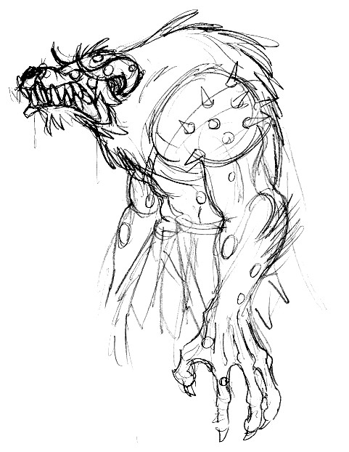
Overview
The aim of this stage is to refine the functionality of the adventure game from stage one of this project.
The player must now have (among many other optional things) the following two attributes:
- health: indicates how healthy the player is. Range: (0..99). If the health reaches zero (or below), the player dies. Health can be gained by healing (first aid kits, other characters with healing powers, …) or naturally over time. Health can be lost through injuries, poisoning, etc.
- food: indicates how hungry the player is. The lower the food value, the hungrier the player. Range: (0..99). If the food value reaches zero, the player dies (starved to death). The food value can be increased by eating (non-poisonous) food. Every move (every command) decreases the food value. Going to a neighbouring room, for example, consumes 3 food points. (It is your choice whether the food consumption is the same for all activities, or whether some actions make you more hungry than others…).
To support this, some items must have a food value, others must have a healing value. (Maybe all items have these attributes, and the value is just set to zero for non-eatable, non-healing items? Or maybe you use subclasses? Your decision – discuss.)
And now for the fun part…
One major aim of this stage is to enable characters to be exchanged between games and dynamically loaded. One project group should be able to take, say, a dwarf from another group and insert it (without need for recompilation) into their own game.
Every group is expected to make at least three different characters available to others, and insert several characters from other groups into their game. Characters, when talked to, may reply with a (maybe useful?) remark, and they may drop items in the current room.
If you give an item to a character, it may take, consume, reject, … the item and also respond (give you something, tell you something, kill you, …)

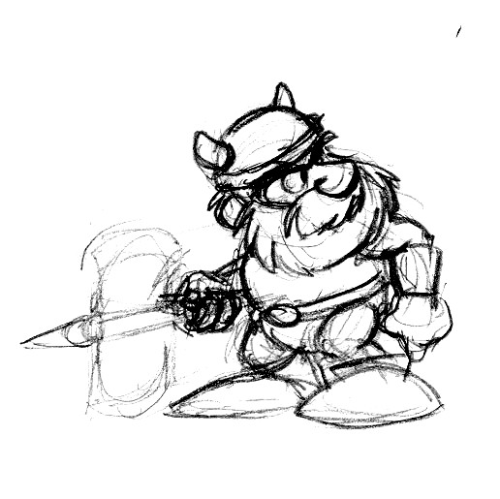
Requirements
The following are minimum requirements that must be fulfilled. Experimentation beyond this minimum is encouraged.
- There exists a helpful character that heals you if you talk to it while being injured, or gives you food if you are hungry. However, it does not stick around – it walks away after doing this.
- There exists a dangerous character that harms you (causes you to lose health points) whenever you try to talk to it.
- There is a neutral character that gives you an item you need for the game in return for handing him/her something he/she wants.
- Character classes dynamically loaded. We suggest that characters are stored in a known location where they are found by the simulation.
- You must exchange characters with at least one other project group.
- You are expected to continue the XP style development process.

Suggestions
- Characters should probably have both icon and colour, so that different visualisations can choose how to display them. They should probably specify a name.
- You must agree on a common Character interface (at least), possibly also an item interface (characters may rely on items). You may extend the interface provided in the first stage of this project.
- It would probably be good to form larger groups of projects (more than two) and agree on an interface. I would suggest maybe one to three interface standards across the class.
- Use the discussion group for communication.

Deliverables, deadline and assessment
The complete project source code must be submitted by email to your lecturer on or before the due date.
The project will be demonstrated to the whole class at the end of the course in weeks 20 and 21. You will have to hand in a report at the and of project stage 3, which also includes discussing this project stage. (This is a hint: it may be a good idea to start writing, or at least to take notes.)
There is no separate assessment for this stage of the project. However, completing this project is a prerequisite for attendance of the final exam.

